**Pankaj Kumar**

**SAP ERP Configuration Phase I Exercise**

**Total 60 points**

Follow all the steps in the handout “SAP ERP Configuration Phase-I Financial Accounting.”

Then in the Part 1.4-Process Execution do the following:

1. Submit a screenshot of Display G/L Account Centrally (page 139) (12 points)

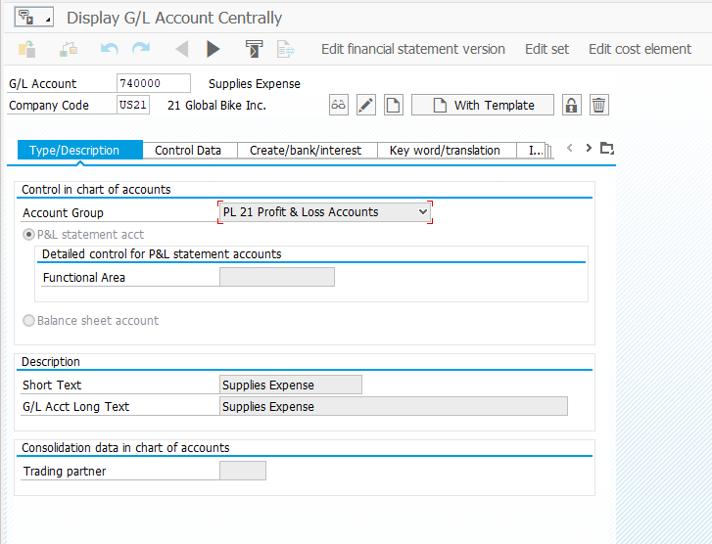

1. Submit a screen shot of G/L Account Balance Display (page 141) (12 points)

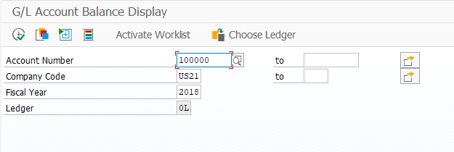

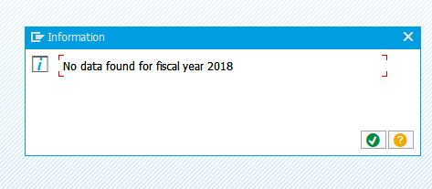

1. Submit a screen shot of Enter G/L Account Document: Company Code USXX (page 145) (12 points)

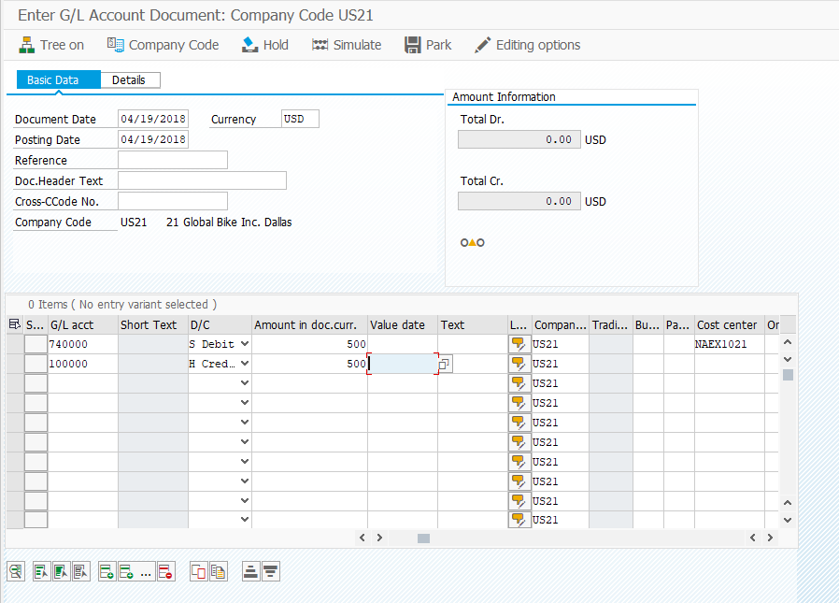

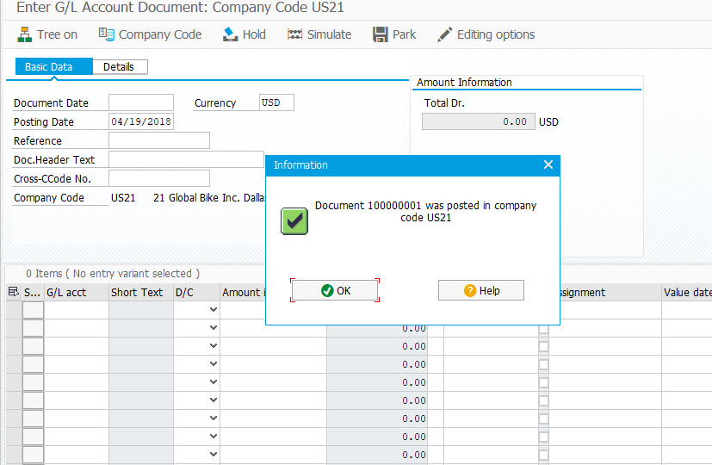

1. Submit a screen shot of G/L Account Balance Display (page 147) (12 points)

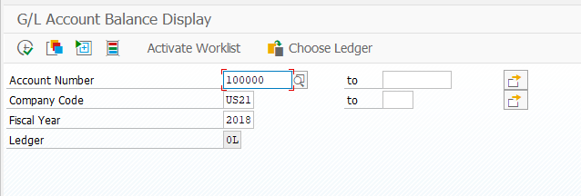

1. Submit a screenshot of Balance Display: G/L Accounts for the Ledger OL (page 148) (12 points)

